Declarative Peephole Optimization Using String Pattern Matching

Abstract:
Peephole optimization as a last step of a compilation sequence capitalizes on significant opportunities for removing low level code slackness left over by the code generation process. We have designed a peephole optimizer that operates using a declarative specification of the optimizations to be performed. The optimizer's implementation is based on string pattern matching using regular expressions. We used this approach to prototype an optimizer to convert target machine instruction sequences containing conditional execution of instructions inside loop bodies into code that adaptively executes the optimum branch instructions according to the program's branch behaviour.
The peephole optimizer applies a set of pattern-matching rules to the code, with the goal of replacing inefficient sequences of instructions with more efficient sequences. A second goal is to perform some register usage optimizations based on variable lifetimes
Redundant instructions may be discarded during the final stage of compilation by using a simple optimizing technique called peephole optimization. The method is described and examples are given.

Keywords
Peephole optimization; branch prediction; regular expressions.

1 Introduction
Peephole optimization as a last step of a compilation sequence capitalizes on significant opportunities for removing low level code slackness left over by the code generation process. In addition, as peephole optimizer work on low level (target) code they can perform transformations based on specific characteristics of the target architecture. The declarative specification and implementation of the peephole optimization process can offer a number of advantages over the procedural coding of the same specification:
- the implementation cost of the optimizer is only that of the specification of the optimizations to be performed,
- the correctness of the resulting implementation only depends on the correctness of the initial specification, and
- Reasoning, documentation, and maintenance of the optimizer can be performed at the specification level.
The emergence of versatile text processing languages and high quality regular expression libraries has allowed us to experiment with a peephole optimizer design based on regular expression string pattern matching. In the following sections we describe a prototype implementation of a flow-of-control optimizer based on the declarative specification of optimization patterns and their dynamic compilation into regular expression replacement sequences. We have used this optimizer to implement a software-based dynamic jump prediction scheme.
The remainder of this paper is structured as follows: Section 2 introduces the optimizer's design; Section 3 describes our motivating example based on a software-based dynamic branch prediction scheme, while Section 4 details the optimizer's implementation. The complete listing of the optimizer prototype implementation is provided as an Appendix.

2 Optimizer Design
The optimizer's design is based on pattern matching of the target code against declarative specifications as illustrated by the dataflow diagram in Figure 1. The optimizer initially converts the declarative -- domain specific optimization specification into a string regular expression that can be applied to an appropriate representation of the target code. As a trivial example Figure 2 contains a declarative optimization specification for the elimination of jumps to jump instructions. The specification is written as a pattern to be recognized followed by the corresponding replacement code. The optimizer reads the target code, converts it into a string, storing relevant ancillary information into a lookup table, and then continuously applies the regular expression to the string representation of the target code performing the specified pattern-based substitutions. The repetitive nature of the regular expression application can result in higher order optimizations where the output code of one optimization step is further optimized by the next application. Finally, the string representing the optimized target code is converted back into its normal representation based on the lookup table.

Figure 1:
The peephole optimizer dataflow diagram.
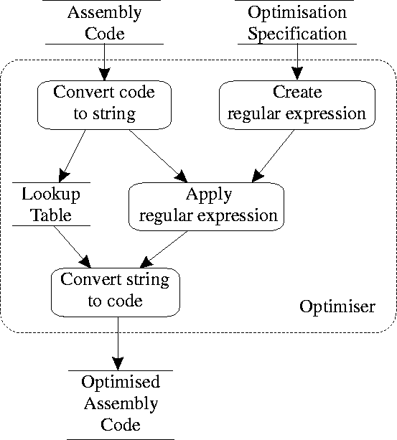

Figure 2: Simple declarative specification for eliminating jumps to jump instructions.
# Input pattern
jmpL1
S1*
L1: jmpL2
=>
# Output specification
jmpL2
S1*
L1: jmpL2

3 Optimizing Dynamic Branch Prediction
We tested the design of the optimizer using as a motivating example the optimization of branch instructions. Modern processors make extensive use of overlapped instruction execution -- pipelining -- to increase their performance. This performance gain is not realized to its full potential due to the existence of hazards: conditions that prevent the execution of parallel instructions. Control hazards arise from the pipelining of instructions such as branches that change the program counter (PC). In this case the fetching and execution of instructions that follow a conditional branch instruction are stalled until the branch location is determined. It is possible to reduce pipeline stalls by predicting the program flow and arranging for the appropriate instructions to be fetched. In our example we use a loop code generation technique that results in code that adaptively follows a predicted branch path.

3.1 Branch Prediction Methods
Branch prediction methods can be broadly distinguished between static methods where the probable direction of program flow is determined before the program execution and dynamic methods where branches are predicted during the program's execution by some measure of previous branch history. Static branch prediction methods compile branches assuming that a given branch will be taken or not taken according to various heuristics. The scheme can be improved by using profiling data from previous runs of the code. Dynamic schemes depend on hardware memory which is used to store the behaviour of branch instructions in their previous executions. Given the finite amount of storage that can be used to store the behaviour of all branch instructions in a program, hashing and LRU-buffer techniques are used to store predictions about a subset of the branch instructions. In the case of branches that are usually not taken a one-bit prediction scheme will result in two wrong guesses when a branch is taken. In order to avoid this situation an additional bit can be used to provide a second order prediction behaviour. A branch prediction buffer can be further extended into a branch target buffer by storing in the buffer the actual branch target instruction, thus gaining an instruction fetch cycle.

3.2 Adaptive Code
Instruction sequences containing conditional execution of instructions inside loop bodies can be compiled into code that adaptively executes the optimum branch instructions according to the program's branch behaviour. A loop body containing an if-then-else conditional statement is compiled into two loop sequences: one sequence compiled for optimum behaviour when the then branch is taken, and one compiled for optimum behaviour when the else branch taken. For both sequences the code body for the part which is predicted not to be executed is replaced with a branch to the corresponding code of the other sequence. Thus, the code in Figure 3 is compiled using branches with a high taken penalty as shown in Figure 4. The technique is applicable to many different loop code sequences containing conditional branches.

Figure 3: Sample loop code.
LOOP
statement-1
IF condition THEN
statement-2
ELSE
statement-3
FI
statement-4
END LOOP

Figure 4: Dynamic loop compilation sequence.
L1: statement-1
test condition
branch if not condition L4
L2: statement-2
statement-4
branch L1
L3: statement-1
test condition
branch if condition L2
L4: statement-3
statement-4
branch L3

4 Implementation
In order to test out our approach we implemented a prototype optimizer and used it to implement the dynamic branch prediction scheme described above.
The optimizer first reads the compiler's target language output and converts all lines into strings composed of three token classes:
labels
which are converted into the character L followed by an integer identifying the label,
branch instructions
which apart from the target label are not modified, and
other code
which is replaced by the character S followed by an integer identifying that code.
A lookup table is built to convert the L and S tokens back to the original target code labels and instructions. The following is a formatted sample fragment of tokenized target code:
S0025 L0000: S0026 S0027 jeL0001 S0028
jmpL0002 S0029 L0001: S0030 L0002: S0031
jmpL0000 S0032 S0033 S0034 S0035
The optimizer then reads the declarative specification of the optimizations to be performed. Figure 5 contains the optimization specification for the one-bit loop optimization. The specification is written as a pattern to be recognized and the replacement code.
The pattern to be recognised can consist of:
Label specifications
Names starting with L followed by digits,
Jump instructions
Written as they appear in the target code output, and
Code place-holders
For all other code represented by names starting with S followed by digits.
Sn place-holders can be followed by a trailing Kleene star (*) to specify an arbitrary number of instructions.

Figure 5: Example of optimizer input pattern and output specification.
# Input pattern
L1:
S1*
jeL2
S2*
jmpL3
S5*
L2:
S3*
L3:
S4*
jmpL1
=>
# Output specification
N1:
S1
je N2
N4:
S2
S4
jmp N1
N3:
S1
jne N4
N2:
S3
S4
jmp N3

The replacement text is separated from the code pattern by a `=>' symbol and consists of:
New label specifications
Names starting with N followed by digits; these are replaced by unique label identifiers,
Literal output
Written as it will appear in the target code output, and
Pattern specification place-holders and labels
Names starting with S or L followed by digits; these are copied from the matched pattern.
The input pattern is converted into an extended string regular expression with the appropriate tokens replaced with back-references to the tokens in the previous part of the expression. Thus the pattern specification in Figure 5 is translated into the following regular expression (+ means any number of digits and number is a back-reference to a previous bracketed expression):
(L\d+):(S\d+)*je(L\d+)(S\d+)*jmp(L\d+)
(S\d+)*\3:(S\d+)*\5:(S\d+)*jmp\1
the corresponding replacement specification ($number is a reference to a bracketed part of the regular expression):
$N1: $2
je $N2
$N4: $4
$8
jmp $N1
$N3: $2
jne $N4
$N2: $7
$8
jmp $N3
and code to increment the label variables $N.
The optimizer works by continuously matching the input regular expressions against the tokenized program and replacing the matched part with the specified output code. When no more matches can be performed the tokenized program is converted back into normal target code using the lookup table built in the first phase to derive the optimized target code.
The declarative specification of the optimization operations and the use of string regular expressions for code pattern matching resulted in a flexible and compact implementation. The optimizer is currently a 127 line program written in Perl. It has been tested on Intel iAPX86 assembly output generated by the Microsoft C compiler.

5 Conclusions
So far the approach and the optimizer have only been tested on small example programs, a single optimization specification, and a limited number of flow-of-control optimizations. However, the modest implementation effort invested and the flexibility offered by the parametric, declarative specification of the optimization operations convinced us that this approach can be particularly suitable for rapid prototyping and experimentation with new optimization methods, novel target architectures such as the Java VM, and applications of higher order optimizations.
SOME SITES THAT YOU CAN REFER

http://www.mactech.com/articles/mactech/Vol.15/15.04/CodeOptimization/index.html

http://www.dmst.aueb.gr/dds/pubs/jrnl/1999-SIGPLAN-Optim/html/patop.html

